**Lesson 2 – Settlement Hierarchy**

Aim: To be able to explain settlement hierarchy and how settlements change in services the further away from urban centres.

|  |
| --- |
| Brainstorm – what services should a city have? |
| Medical facilities, education, transportation and large scale shops… |

**Define the following terms:**

**High Order Goods:** stuff you don’t buy daily like devices, shoes or a car  
**Low Order Goods:** condiments like bread rice or water

**High Order Services**: People will travel further for high order services e.g. hospitals or sports stadiums

**Low Order Services:** usually found in villages e.g. a food store

**Task 2:** Using p42 – apply the features of Cloke’s model of rural change to Oman

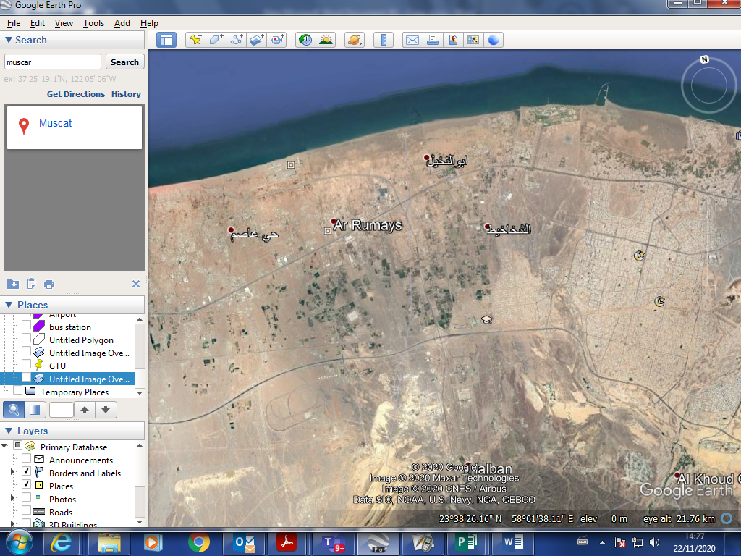

|  |  |  |  |
| --- | --- | --- | --- |
| Extreme rural (national park) | Extreme rural | Extreme non rural | Urban |
| Village with second homes  Declining village (people move to cities – only visit at weekend) | Towns that are not so far from an urban place, a nucleated place but just a bit out in the countryside, Barka or fanja or hamra | Smalls towns  Suburbanised village – people travel to work in urban area |  |

The Settlement Hierarchy

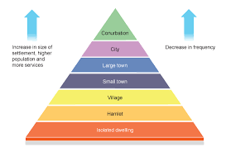

What is a conurbation? Can you think of any examples in Oman?

Seeb muscat

How will high and low order services change with a settlement hierarchy?

Settlement hierarchy can change high and low order services because they might have low order

For each stage of the model can you think of an example from Oman?

|  |
| --- |
| What is meant by the term threshold population? |
| the minimum number of people necessary before a particular good or service can be provided in an area |
| What is meant by the term sphere of influence? |
| A lot of people and a good reason to have services |

Review: Where would you put the images on the settlement hierarchy?

|  |  |
| --- | --- |
| a |  |
| b |  |
| c |  |
| d |  |
| e |  |